CanadaStation
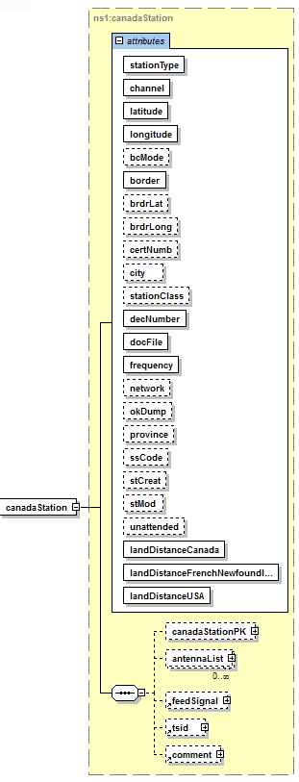
Attribute | Type/UOM | Description
stationType | eCanadaStationType  (String) | The CanadaStation is a consolidated / hybrid record that incorporates fields from the AM, FM, TV and SDAR station descriptions. This abstract object is not used directly, but instead is extended by the AM, FM, TV and SDAR station subtype implementations.
Channel | int | The transmitting CHANNEL; The channel value varies by Station Type and is context dependent.
Latitude | double | N.Latitude used when BORDER last calculated
Longitude | double | W.Longitude used when BORDER last calculated
bcMode | Character | Broadcasting Mode; [S: Stereo, M: Mono, P: Second Audio Channels or B: Both]
border | double | Closest distance to Canada / U.S. Border (km)
brdrLat | String | The latitude coordinates of the closest distance to the US-Canada border.
brdrLong | String | The longitude coordinates of the closest distance to the US-Canada border.
certNumb | String | Broadcasting Certificate Number. Format is "FANNNN"
City | String | The station City name.
stationClass | eCanadaStationType | The (enumerated) Canadian class code of this Station; For Canadian Stations: [A, A1, B, C, C1, LP, VLP] For Non-Canadian Stations: [A, B, B1, C, C1, C2, D]
decNumber | Int | Canadian Radio-television and Telecommunications Commission (CRTC) Decision Number. Format is "YYNNNN"
docFile | int | Industry Canada document file number
frequency | double | Broadcast frequency in MHz.  (NOTE: AM Station frequencies are originally recorded in kHz but are automatically converted to MHz upon import into the ca_station table.
network | String | The broadcast Network (CBCE, CBCF, IND, INDE, INDF, BCMH, or none)
okDump | dateTime | Last date of record update for the "Consultants" database export dump
province | String | The station province (Canada) or state (US) is located.
ssCode | String | Short spacing code; "*O#aa"
stCreat | dateTime | Date the station was first entered in the database
stMod | dateTime | Date the station record was last modified in the database
unattended | Character | Unattended operation code (Y, N)
landDistanceCanada | Double | Closest distance to Canada land edge
landDistanceFrenchNewfoundland | Double | Closest distance to French Land edge near Newfoundland
landDistanceUSA | Double | Closest distance to USA land edge

Element | Type/UOM | Description
canadaStationPK | canadaStation | The (Enumerated) station type discriminator. This column is used to  * identify the type of station in the database that this record represents.  * <p/>  * Supported valued are: [AM, FM, SDAR, TV].
antennaList | List of Antennas | List of Antenna objects. In the Canada database each antenna record describes a different polarization for the same physical antenna.
feedSignal | FeedSignal | Feed Signal table reference. This defines the source of a feed signal for a TV service.
tsid | Tsid | A 16-bit packet contained within the Extended Data Services (XDS) of EIA-608B.
comment | Comment | Comment table reference containing user information.

CanadaStationTV
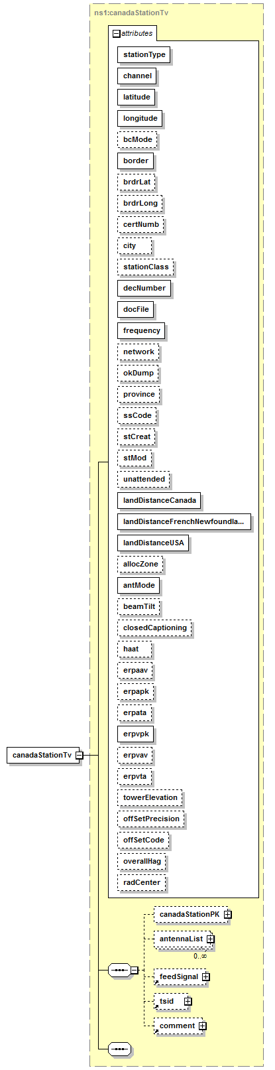
Attribute | Type/UOM | Description
stationType | eCanadaStationType  (String) | The CanadaStation is a consolidated / hybrid record that incorporates fields from the AM, FM, TV and SDAR station descriptions. This abstract object is not used directly, but instead is extended by the AM, FM, TV and SDAR station subtype implementations.
Channel | int | The transmitting CHANNEL; The channel value varies by Station Type and is context dependent.
Latitude | double | N.Latitude used when BORDER last calculated
Longitude | double | W.Longitude used when BORDER last calculated
bcMode | Character | Broadcasting Mode; [S: Stereo, M: Mono, P: Second Audio Channels or B: Both]
border | double | Closest distance to Canada / U.S. Border (km)
brdrLat | String | The latitude coordinates of the closest distance to the US-Canada border.
brdrLong | String | The longitude coordinates of the closest distance to the US-Canada border.
certNumb | String | Broadcasting Certificate Number. Format is "FANNNN"
City | String | The station City name.
stationClass | eCanadaStationType | The (enumerated) Canadian class code of this Station; For Canadian Stations: [A, A1, B, C, C1, LP, VLP] For Non-Canadian Stations: [A, B, B1, C, C1, C2, D]
decNumber | Int | Canadian Radio-television and Telecommunications Commission (CRTC) Decision Number. Format is "YYNNNN"
docFile | int | Industry Canada document file number
frequency | double | Broadcast frequency in MHz.  (NOTE: AM Station frequencies are originally recorded in kHz but are automatically converted to MHz upon import into the ca_station table.
network | String | The broadcast Network (CBCE, CBCF, IND, INDE, INDF, BCMH, or none)
okDump | dateTime | Last date of record update for the "Consultants" database export dump
province | String | The station province (Canada) or state (US) is located.
ssCode | String | Short spacing code; "*O#aa"
stCreat | dateTime | Date the station was first entered in the database
stMod | dateTime | Date the station record was last modified in the database
unattended | Character | Unattended operation code (Y, N)
landDistanceCanada | double | Closest distance to Canada land edge
landDistanceFrenchNewfoundland | double | Closest distance to French Land edge near Newfoundland
landDistanceUSA | double | Closest distance to USA land edge
allocZone | int | Allocation Planning Zone (0, 1, or 2)
antMode | Character | Antenna Mode: O, D, Space; Omnidirectional or Directional
beamTilt | double | Beam tilt angle in degrees (-10.0 to 10.0)
closedCaptioning | Character | Closed captioning (Y or N)
haat | double | Effective height of antenna above the terrain in meters (-1200.0 to 2000.0)
erpaav | double | ERP Aural Average in Watts  0 to 1,000,000
erpapk | double | ERP Aural Peak Power in Watts  0 to 1,000,000
erpata | int | ERP Average Power at Tilt Angle in watts  0 to 5,000,000
erpvpk | double | ERP Visual Peak Power in Watts  0 to over 5,000,000
erpvav | double | ERP Visual Average in Watts  Database range is 0 to 609,000
erpvta | double | ERP Peak Visual Power at Tilt Angle in Watts  0 to over 5,000,000
towerElevation | double | Ground Level at Tower Base above Sea Level in meters.  - to 9,999.9  Database range is 0 to 2995
offSetPrecision | Character | Refers to Off-set Precision. Valid Y, Space.
offSetCode | Character | Refers to TV Off-set Code. Space, +, -, z.
overallHag | double | Overall Height Above ground in Meters  0.0 to 999.9 meters
radCenter | double | Radiating Center Above Mean Sea Level in meters

CanadaStationPK
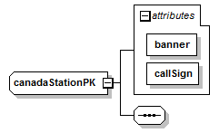

Attribute | Type/UOM | Description
banner | eCanadaBanner | The banner flag (A, C, O, P); the banner’s field can be used to determine whether the station is on or off air
callSign | String | The station’s call sign.

Antenna
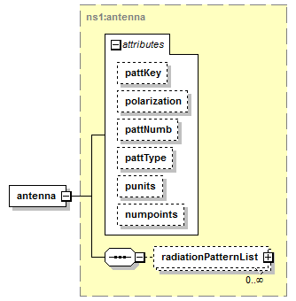

Attribute | Type/UOM | Description
pattKey | int | The Antenna Radiation Pattern Key, this is used to attach RadiationPattern records to this Antenna.
polarization | String | Orientation of the antenna; horizontal or vertical.
pattType | String | The type of antenna pattern.
numpoints | double | The number of points in the pattern.

Element | Type/UOM | Description
radiationPatternList | List of radiationPatterns | A list of 'gains' versus 'angle' data points defining the antenna pattern.

FeedSignal
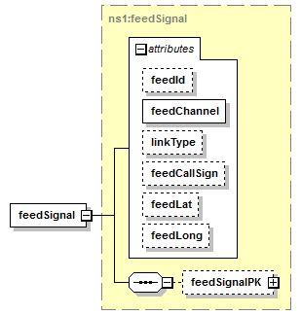

Attribute | Type/UOM | Description
feedId | String | Feed Identifier; A or B
feedChannel | double | Feed input channel: 0, 2-83, or 2500-2680
linkType | String | Type of FEED LINK; O, U, S, C
feedCallSign | String | Name of the SOURCE of the FEED.
feedLat | String | N.Latitude of the FEED SOURCE(ddmmss)
feedLong | String | W.Longitude of the FEED SOURCE(dddmmss)

Element | Type/UOM | Description
feedSignalPK | feedSignal | Logical data model container for the CANADA FeedSignal (feeds) table compound primary key.

TSID
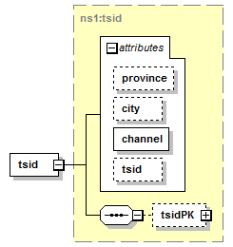

Attribute | Type/UOM | Description
province | String | The station province (Canada) or state (US) is located.
city | String | The station City name.
channel | int | The transmitting CHANNEL; The channel value varies by Station Type and is context dependent.
tsid | String | The Transmission Signal Identifier. A 16-bit packet contained within the MPEG-2 Extended Data Services (XDS) of EIA-608B.

Element | Type/UOM | Description
tsidPK | tsidPK | Compound primary key for the Canada TSID table.

Comment
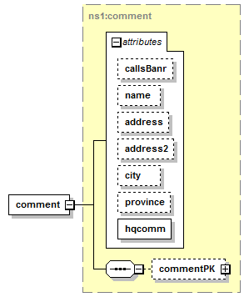

Attribute | Type/UOM | Description
name | String | The entity (company) name.
address | String | The street address.
Adress2 | String | The street address, continued. If present this typically contains a suite number, etc.
city | String | The city.
province | String | The Province (Canada) or State (USA).
hqcomm | int | General Headquarters comment code.

Element | Type/UOM | Description
commentPK | CommentPK | The table compound primary key. This is used to bind the comment record with a CanadaStation record.

